Lab Number: 2
Title: Deadlock avoidance using Banker's Algorithm
Objective: To avoid deadlock using Banker's safety algorithm and resource request algorithm.
Programming Language: Python
IDE/Platform: VS Code
Theory:
The Banker's Algorithm is a deadlock avoidance algorithm which is used by the operating system to check whether allocating requested resources to a process will leave the system in a safe state, before actually granting the request. It treats each process's resource request as a loan request from a bank, only granting resources if the system can still guarantee that all processes can eventually finish. The algorithm requires prior knowledge of the maximum resource needed of each process.
Key terms used:
- Available: A vector indicating the number of available resources of each type.
- Allocation: A matrix showing the number of resources of each type currently allocated to each process.
- Max: A matrix showing the maximum demand of each process for each resource type.
- Need: Need[i][j] = Max[i][j] − Allocation[i][j]; the remaining resources a process may still request.

- Safety Algorithm
It determines whether the system is in a safe state by checking if there exists a sequence in which all processes can complete without leading to deadlock. It works by repeatedly finding a process whose need can be satisfied by the currently available resources, adding its allocation back to the available pool, and marking it finished, until all processes are finished (safe) or no such process can be found (unsafe).
- Resource Request Algorithm
It determines whether a request by a process for additional resources can be safely granted. The request must not exceed the process's declared need or the currently available resources. If both conditions hold, the system pretends to allocate the resources and re-runs the safety algorithm on this hypothetical state; the request is granted only if the resulting state is safe, otherwise the process must wait.

Implementation
Question 1.) Perform Banker's Algorithm (Safety Algorithm and Resource Request Algorithm).

Algorithm:
1: Start.
2: Read n (number of processes) and m (number of resource types).
3: Read the Available vector (m values).
4: Read the Max matrix (n × m).
5: Read the Allocation matrix (n × m).
6: Compute the Need matrix:
for each process i and resource j: Need[i][j] = Max[i][j] − Allocation[i][j]
7: Display the Allocation, Max, Need matrices and the Available vector.
8: Call the Safety Algorithm.
- If it returns TRUE, print “System is in a SAFE state” and the safe sequence.
- Otherwise, print “System is NOT in a safe state (deadlock risk)”.
9: Ask the user whether to test a resource request.
10: While the user answers y:
- Read the process id pid and the request vector Request[m].
- Call the Resource-Request Algorithm with (pid, Request).
- Display the updated state.
- Ask whether to test another request.
11: Stop.

Safety Algorithm (isSafe)

1: Initialize:
- Work[j] = Available[j] for all j
- Finish[i] = false for all i
- count = 0
2: Repeat while count < n:
- Set found = false.
- For each process i from 0 to n−1:
  - If Finish[i] == false and Need[i][j] ≤ Work[j] for all j:
    - Work[j] = Work[j] + Allocation[i][j] for all j (process finishes and releases resources)
    - SafeSeq[count] = i; count = count + 1
    - Finish[i] = true
    - found = true
- If found == false, no process can proceed, return FALSE (unsafe).
3: All processes are finished, return TRUE (safe) with SafeSeq.

Resource-Request Algorithm (requestResources)

1: Claim check. If Request[j] > Need[pid][j] for any j:
print “Process has exceeded its maximum claim” and return FALSE.
2: Availability check. If Request[j] > Available[j] for any j:
print “Process must wait; resources not available” and return FALSE.
3: Pretend to allocate. For every j:
- Available[j] = Available[j] − Request[j]
- Allocation[pid][j] = Allocation[pid][j] + Request[j]
- Need[pid][j] = Need[pid][j] − Request[j]
4: Run the Safety Algorithm.
- If safe, print “Request can be granted safely” and return TRUE (keep the new state).
- If unsafe, roll back:
  - Available[j] += Request[j]
  - Allocation[pid][j] −= Request[j]
  - Need[pid][j] += Request[j]
Print “Request denied: granting it would leave the system unsafe” and return FALSE

Source Code:

#include <stdio.h>
#include <stdbool.h>

#define MAX_PROCESSES 10
#define MAX_RESOURCES 10

int n;
int m;

int Allocation[MAX_PROCESSES][MAX_RESOURCES];
int Max[MAX_PROCESSES][MAX_RESOURCES];
int Need[MAX_PROCESSES][MAX_RESOURCES];
int Available[MAX_RESOURCES];

int i,j;
void calculateNeed() {
for ( i = 0; i < n; i++)
for ( j = 0; j < m; j++)
Need[i][j] = Max[i][j] - Allocation[i][j];
}

void printState() {
printf("\nProcess\tAllocation\tMax\t\tNeed\n");
for ( i = 0; i < n; i++) {
printf("P%d\t", i);
for ( j = 0; j < m; j++) printf("%d ", Allocation[i][j]);
printf("\t\t");
for ( j = 0; j < m; j++) printf("%d ", Max[i][j]);
printf("\t\t");
for ( j = 0; j < m; j++) printf("%d ", Need[i][j]);
printf("\n");
}
printf("\nAvailable: ");
for ( j = 0; j < m; j++) printf("%d ", Available[j]);
printf("\n");
}

bool isSafe(int safeSeq[]) {
int work[MAX_RESOURCES];
bool finish[MAX_PROCESSES] = {false};
for ( j = 0; j < m; j++)
work[j] = Available[j];
int count = 0;
while (count < n) {
bool found = false;
for ( i = 0; i < n; i++) {
if (!finish[i]) {
bool canAllocate = true;
for ( j = 0; j < m; j++) {
if (Need[i][j] > work[j]) {
canAllocate = false;
break;
}
}
if (canAllocate) {

for ( j = 0; j < m; j++)
work[j] += Allocation[i][j];

safeSeq[count++] = i;
finish[i] = true;
found = true;
}
}
}

if (!found) {

return false;
}
}

return true;
}

bool requestResources(int pid, int request[]) {

for ( j = 0; j < m; j++) {
if (request[j] > Need[pid][j]) {
printf("Error: Process P%d has exceeded its maximum claim.\n", pid);
return false;
}
}
for ( j = 0; j < m; j++) {
if (request[j] > Available[j]) {
printf("Process P%d must wait; resources are not available.\n", pid);
return false;
}
}
for ( j = 0; j < m; j++) {
Available[j] -= request[j];
Allocation[pid][j] += request[j];
Need[pid][j] -= request[j];
}
int safeSeq[MAX_PROCESSES];
if (isSafe(safeSeq)) {
printf("Request can be granted safely.\n");
return true;
} else {
for ( j = 0; j < m; j++) {
Available[j] += request[j];
Allocation[pid][j] -= request[j];
Need[pid][j] += request[j];
}
printf("Request denied: granting it would leave the system unsafe.\n");
return false;
}
}
int main() {
printf("=== Banker's Algorithm - Deadlock Avoidance ===\n\n");

printf("Enter number of processes: ");
scanf("%d", &n);
printf("Enter number of resource types: ");
scanf("%d", &m);

printf("\nEnter Available resources vector (%d values):\n", m);
for ( j = 0; j < m; j++)
scanf("%d", &Available[j]);

printf("\nEnter Max matrix (%d x %d):\n", n, m);
for ( i = 0; i < n; i++) {
printf("Process P%d: ", i);
for ( j = 0; j < m; j++)
scanf("%d", &Max[i][j]);
}

printf("\nEnter Allocation matrix (%d x %d):\n", n, m);
for ( i = 0; i < n; i++) {
printf("Process P%d: ", i);
for ( j = 0; j < m; j++)
scanf("%d", &Allocation[i][j]);
}

calculateNeed();
printState();

int safeSeq[MAX_PROCESSES];
if (isSafe(safeSeq)) {
printf("\nSystem is in a SAFE state.\nSafe sequence: ");
for ( i = 0; i < n; i++)
printf("P%d ", safeSeq[i]);
printf("\n");
} else {
printf("\nSystem is NOT in a safe state (deadlock risk).\n");
}

char choice;
printf("\nDo you want to test a resource request? (y/n): ");
scanf(" %c", &choice);
while (choice == 'y' || choice == 'Y') {
int pid;
int request[MAX_RESOURCES];
printf("Enter process number requesting resources (0 - %d): ", n - 1);
scanf("%d", &pid);
printf("Enter request vector (%d values): ", m);
for ( j = 0; j < m; j++)
scanf("%d", &request[j]);
requestResources(pid, request);
printState();
printf("\nTest another request? (y/n): ");
scanf(" %c", &choice);
}
return 0;
}

Output Section:

Q.1 Output:
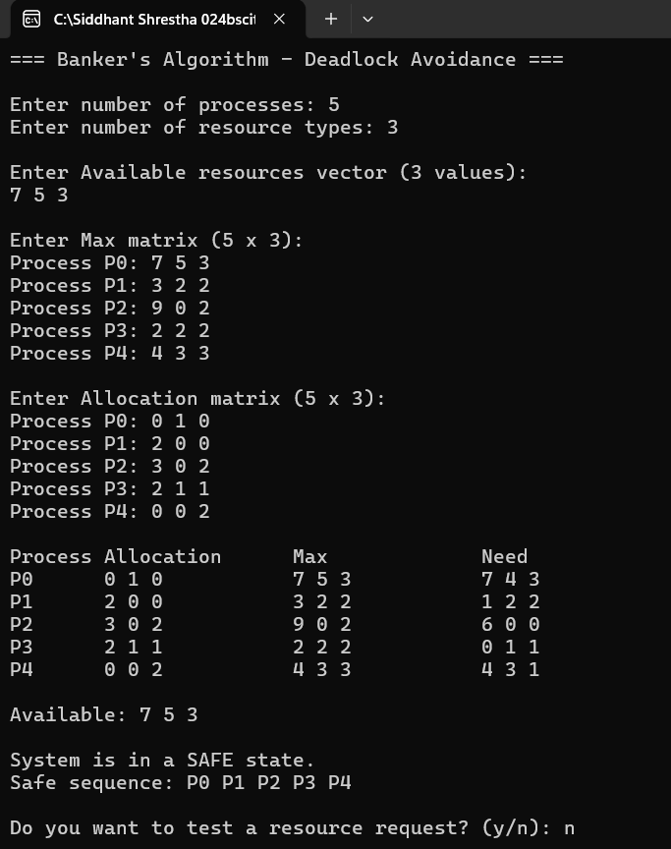

Discussion:
The Banking Algorithm’s effectively prevented deadlock by verifying that the system remained in a safe state before allocating resources. First, the Need matrix was calculated from the Allocation and Maximum matrices. The Safety Algorithm then checked whether all processes could complete successfully and produced a safe execution sequence, confirming that the current state was safe. When a process requested additional resources, the algorithm ensured the request did not exceed the process's remaining need or the available resources. It then temporarily allocated the resources and ran the Safety Algorithm again to confirm the system would remain safe before approving the request. This demonstrates how the algorithm avoids deadlock by making allocation decisions only when they preserve system safety.

Conclusion:
The Banker's Algorithm is a reliable deadlock avoidance technique that grants resource requests only if they keep the system in a safe state. By using the Safety Algorithm before every allocation, it guarantees that all processes can complete without causing deadlock. Although it introduces some computational overhead and requires processes to specify their maximum resource requirements in advance, it remains an effective method for maintaining safe resource allocation in operating systems.

